Name – Akshat Bhargava

Roll no – 22563

DS – SL3

Prac 4

Code:

1. Import libraries and load ‘HousingData.csv’ dataset.

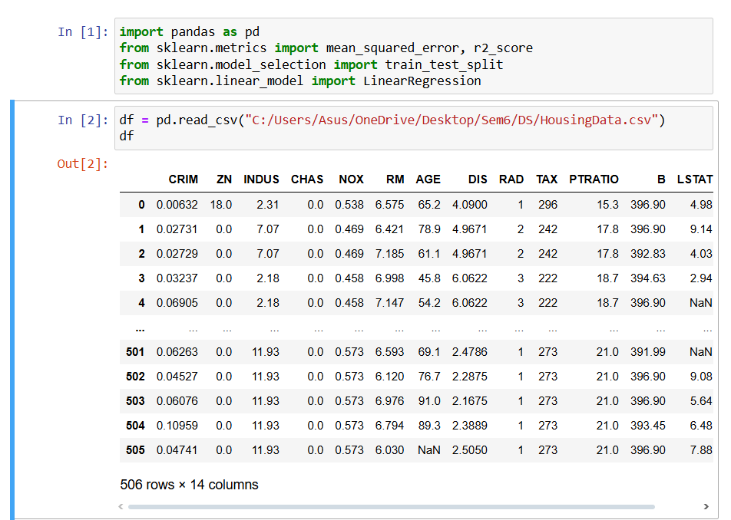

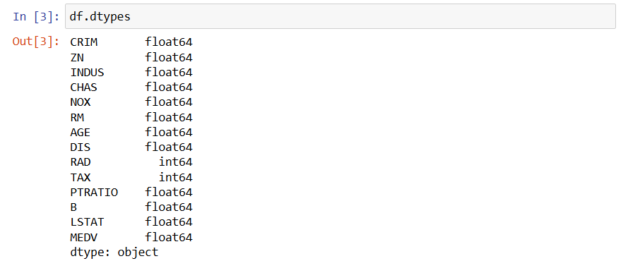

1. Remove or fill null values.

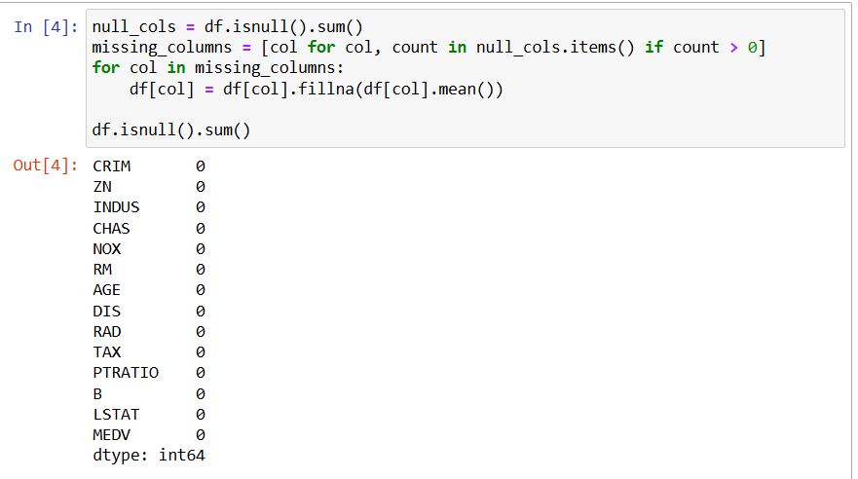

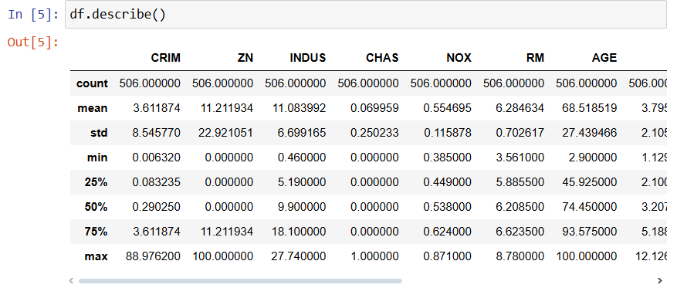

1. Create a Linear Regression Model using Python/R to predict home prices using Boston Housing Dataset.

